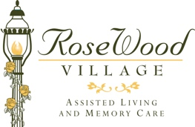
October 15, 2020

Dear RoseWood Village Friends and Families,

As RoseWood Village Greenbrier cautiously continues to move forward with our reopening plan, your loved one’s health and safety remain our utmost concern. While we are still not allowing visitors, we continue to move forward within the community and are happy to announce that our Beauty Shop Services will resume starting October 22nd. The Beautician will be available Thursdays and Fridays.
Our Beautician will follow safety protocols and guidelines recommended by the guidance we’ve received from the CDC and VDH and guidance from the Virginia Board of Barbers and Cosmetologists. We will be staggering resident appointments to allow time to sanitize after each resident appropriately. As the Beauty Shop opens up, we want to ensure that all our residents interested in receiving beauty shop services will be scheduling appointments internally at this time. If you do not wish your loved one to be seen, please call and let our concierge know.
We will continue to require our team and encourage residents to wear masks at all times, screen residents and team members daily, and practice social distancing.
We feel that keeping these essential measures in place will continue to keep our residents safe. We understand how stressful these restrictions are for everyone. We are doing our best to keep our resident’s health and well-being, our number one priority.
Our expectation and hope is to continue to move forward in our reopening phases with guidance from the CDC and the Virginia Department of Health.
We are thankful for the continued support of our families and community during this time.
If you have any questions, we are here for you. Please call us at 434-975-5079.Kind Regards,

Christine Wright, LPN, ALFA, CDP

Executive Director, RoseWood Village at Greenbrier

